Name ________________________________

1. (10 pts)Write the Java statement that will declare an array for the following table: (you do not need to assign the values – just the declaration statement).

|  |  |  |
| --- | --- | --- |
| 6.48 | 27.5 | 6.35 |
| 5.36 | 9.5 | 75 |
| 5 | 45 | 8.68 |
| 73.6 | 8.5 | 48.2 |

1. (10 pts)Explain how the three visibility modifiers work.
   1. Protected
   2. Public
   3. Private
2. (10 pts)Define/Contrast interfaces and abstract classes.
3. (10 pts)What is/are the benefits of using Generics? Why use Generics?
4. (20 pts)Write a generic class below called **GenData**. It should contain a single variable called DATA. It should have a single constructor that takes an argument and stores it in DATA. It should also have the appropriate get and set methods for manipulating DATA.
5. (15 pts)Given the class you implemented previously, in the main class below, write the code to create 2 objects of **GenData** type. Make an object store a String and the other a Double. (remember, generics don’t work with primitive types)

public class main {

public static void main(String[] args) {

}

}

1. (15 pts)Wiggles functions, are defined recursively as follows:

W(n) = 1 for n = 0

W(n) = 2 for n = 1

W(n) = W(n – 2) * W(n - 1) * n for n > 1

Write the Java recursive function for Wiggles.

1. (10 pts)Suppose you have three classes; **Apple**, **Orange**, and **Banana**, and all three classes inherit from a class called **Fruit**. Given the main method below, write a SINGLE method called PrintType that can be used for all three statements. (Assume there is a toString() method for each class that just prints out the classes information. This should be what is printed in the PrintType method.)

public class example1

{

public static void main(String[] args)

{

//Print out the Fruit Information

print(new Orange());

print(new Apple());

print(new Banana());

}

}

1. (10 pts)Consider the exception block below. Suppose that Statement3 has a problem and throws an exception. What is the output of the following block of code?

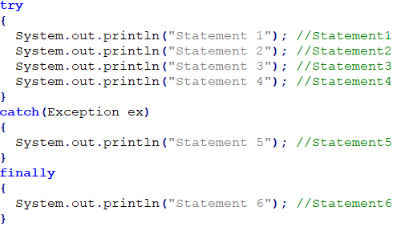

1. (15 pts)Answer the following questions concerning files.
   1. Give advantages of using binary files.
   2. What is the purpose of the Serializable interface?
   3. How is a Random Access file different? How does it read/write by?

For Questions 11-13 consider the following UML Diagram.

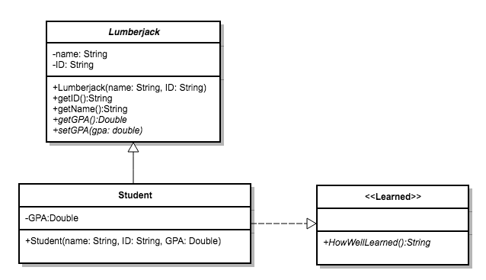

1. (50pts)Implement the **Student** class below. The **HowWellLearned** method should just return a string indicating how good the student felt about his or her education.
2. (25 pts)Consider the following Exception class. Rewrite your setGPA method below utilizing this exception class. If the GPA entered is not at least a 2.0, then this method should throw the exception. Otherwise it should set the GPA to the value given.

public class InvalidGPAException extends Exception

{

InvalidGPAException()

{

}

public string errorMessage()

{

return "Invalid GPA. Must be a minimum of 2.0";

}

}

1. (25 pts)Consider the following block of code and Main Method. The current object has an invalid GPA being entered. Rewrite the main method that will handle the error caused in the code displaying the error message being thrown by the **Student** class.

public static void main(String[] args)

{

Student student1 = new Student("JimJim", "12345678", 0.0);

student1.setGPA(1.2);

}

1. (10 pts)What are the commands in UNIX for the following tasks?
   1. To compile the file **finalExam.java**?
   2. To run the file **finalExam.java**?
   3. To submit the file **tada.java** using the account csci230299?
2. (15 pts)Define the following terms:
   1. Abstraction
   2. Encapsulation
   3. Inheritance
   4. Polymorphism
   5. Immutable

Bonus: (5 pts)When talking about Multi-Threading, we discussed a few potential problems. One of them was something called Race Condition. What are Race Conditions in this context?